Lab 5.1

POLYMORPHISM

Payroll Calculation

Objectives:
- Practice implementing and using polymorphic methods.
- Understand how the Template Method design pattern works.

Human Resource Application:
The HR department has identified three types of Employees based on how they are paid: Hourly, Salaried, and Commissioned. The paycheck for each type is calculated differently:

- Hourly employees are paid monthly and their paycheck amount is calculated based on their hourly wage and the hours per week they work. For simplicity just assume four weeks for each month.

- Salaried employees are paid monthly and their paycheck amount is a fixed amount every month.

- Commissioned employees are also paid monthly. They receive a small base salary, plus a percentage (commission) on the total value of all orders they sold during that month.

Lab 5.1 Page 2

Class Diagram for Payroll System
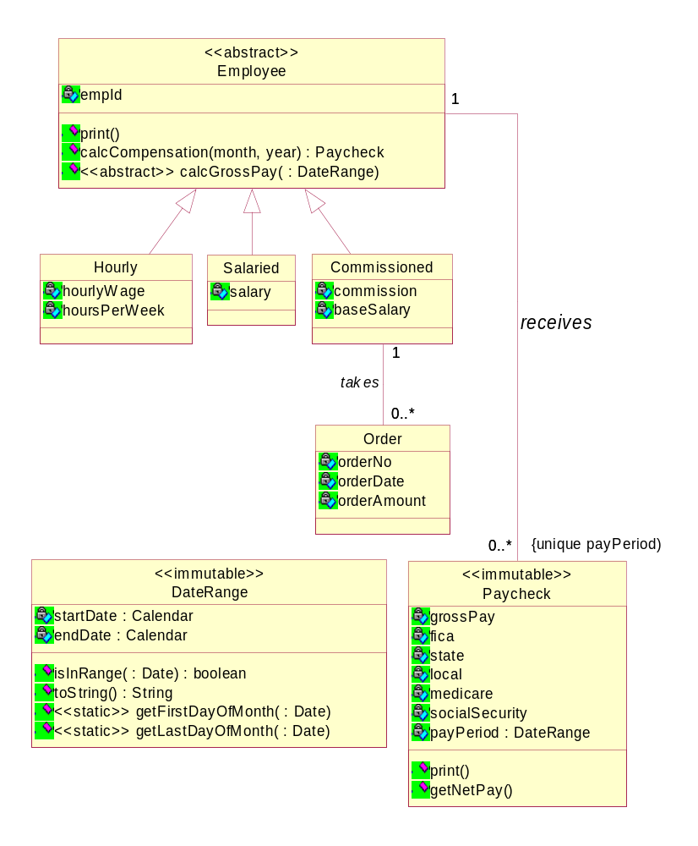
The DateRange class is provided and contains the necessary functionality to determine a pay period's start and end date. The toString() method returns the start and end date in a string.
Lab 5.1 Page 3

Tasks:

- Add a concrete calcCompensation() method to Employee.

  - This method takes the month and year as arguments for which to calculate the compensation. Both are of type integer.
  - For hourly and salaried employees the amount is the same every month.
  - For Commissioned employees the amount depends on the orders they sold that month.

- The Employee calcCompensation() method delegates to the respective derived class to calculate the gross pay amount by invoking the abstract Employee.calcGrossPay() method.

- The Employee.calcCompensation() method then calculates the FICA, state & local taxes, medicare and social security contributions based on the gross pay. Assume the following fixed tax percentages:

  - FICA is 23%
  - State tax is 5%
  - Local tax is 1%
  - Medicare is 3%
  - Social Security is 7.5%

Once it calculates the gross pay and all the tax amounts it creates a PayCheck object and passes all those values to the constructor.

Important details about the UML class diagram:

- Paycheck class are immutable, i.e. all data needs to be passed to the constructor and no setter methods should be provided.

- Paycheck records the payPeriod which is a date range stored as a string, e.g.
"2/1/06 – 2/28/06"
The pay period is assumed to be from the first day of the given calendar month until the last day of that month.

- Employee is an abstract class!

- Employee.calcCompensation() returns a Paycheck object!

- In order to calculate the paycheck for a Commissioned employee you need to access all the Order objects that each Commissioned employee is responsible for and add up the order amount of all orders during a given month.

  - A simpler version would be sufficient where we just sum up the amounts of all orders irrespective of the order date. Don't spend much time on date manipulation!

- Commission in the Commissioned class refers to the commission rate. Assume 7%.

Hard code All of the object creation!

You Must use polymorphism when appropriate!!
Ask the students “Where is it appropriate?”

----------------------------------------------------------------------------------------------------------------

After all of the above is done, in the Main class, print out all of the employees and for each employee print out all of their paychecks. SEE NEXT PAGE!

----------------------------------------------------------------------------------------------------------------

Level 3 : Put in Orders for DIFFERENT months, and process only the one month that you want, only the month that isInRange.

